An On-Device Deep Learning Framework to Encourage the Recycling of Waste

Oluwatobi Ekundayo¹, Lisa Murphy¹, Pramod Pathak (PhD)¹ and Paul Stynes (PhD)¹
¹ National College of Ireland, Mayor Street, IFSC, Dublin 1, Ireland.
paul.stynes@ncirl.ie

Abstract. Only 4% of household waste generated in Africa is recycled. Current research uses machine learning models in cloud-based solutions to classify waste. However, in countries with limited internet access, there is a need to increase user engagement in classifying waste using an on-device approach. Developing a machine learning model for a mobile device with limited size and speed is a challenge. This research proposes an on-device deep learning framework to encourage the recycling of household waste. The proposed framework combines an optimal deep learning image classification model and gamification elements. A combination of multiple waste datasets named WasteNet consisting of 33,520 images is used to train the deep learning image classification model using seven classes of recyclable waste namely e-waste, garbage, glass, metal, organic, paper and plastic. Data augmentation and transfer learning techniques are applied to train five models on a mobile device namely, MobileNetV2, VGG19, DenseNet201, ResNet152V2 and InceptionResNetV2. Results of the five models are presented in this paper based on accuracy, loss, latency and size. This research shows promise for InceptionResNetV2, MobileNetV2 and DenseNet201in encouraging householders to engage in recycling waste using gamification on a mobile device.
Keywords – Waste, Deep Learning, Image Classification, Gamification, Recycling, Quantization

Introduction

An estimated 70–80% of household waste generated in developing countries such as Africa is recyclable, however, only 4% of the waste is currently recycled [1]. Householder engagement in classifying recyclable waste is a challenge. Deep learning image classification models such as AlexNet and VGGNet can improve the accuracy of classifying waste. These models are developed using cloud-based approaches and require large memory and computational power [2]. Householders typically use a mobile device to classify waste for recycling. In developing countries, mobile devices may have limited internet access. Therefore, an on-device approach is required. Size and speed are limitations with a mobile device and therefore light-weight machine learning models are required.
The aim of this research is to increase householder engagement to classify waste for recycling. The major contribution of this research is a novel on-device deep learning framework that combines an optimal deep learning image classification model and gamification elements that encourages the recycling of waste. A minor contribution of this research is a new waste image dataset, WasteNet that combines several waste datasets. WasteNet consists of 33,520 images with seven classes of recyclable waste namely e-waste, garbage, glass, metal, organic, paper and plastic. In order to identify the optimal deep learning model this research compares MobileNetV2, VGG19, DenseNet201, ResNet152V2 and InceptionResNetV2. Based on accuracy, loss, latency and size, a model was selected for the deep learning framework.
Gamification as the use of game design elements within non-game contexts such as waste recycling. Game design elements such as experience points (XP), challenges, achievements, leaderboard and rewards are responsible for user engagement. A gamification strategy shows promise in engaging householders in order to recycle waste.
This paper discusses deep learning models used for waste classification and application of gamification to waste management in section 2 related work . The research methodology is discussed in section 3. Section 4 discusses the design components for the on-device deep learning framework. The implementation of this research is discussed in section 5. Section 6 presents and discusses the evaluation results. Section 7 concludes the research and discusses future work.

Related Work

Smart waste management systems are starting to improve waste recycling. Santti et al. developed a mobile game application to motivate householders to recycle waste [3] using gamification elements. Results show that the use of gamification increased the recycling rate for bio-waste from 76% to 97%. After their pilot launch, a significant increase of 25% to 85% was seen for the recycling rate of plastics. Santti et al. [3] indicated that future research should include machine learning with gamification in order to recycle waste. Current research into smart waste management systems are implementing deep learning models to improve recycling processes such as Support Vector Machines (SVM), Convolutional Neural Network (CNN) [4], ResNet50+SVM [5], MobileNet, InceptionResNetV2, DenseNet121, Xception [6] and Very Deep Convolutional Neural Network for Large-Scale Image Recognition VGG [7].
Yang and Thung [4] compared SVM and CNN to automatically classify waste into six recycling categories. These models were trained using the Trashnet dataset. The Trashnet datasets consisted of 2400 images based on six recycling categories namely cardboard, paper, glass, metal, trash and plastic. Two classes of this dataset, cardboard and paper belong to the same category and categories such as organic and e-waste were not captured. Adedeji and Wang [5] and Bircanoğlu et al. [6] trained their models based on the Trashnet dataset. A larger dataset size would assist with providing more accurate mean values. For this reason, a waste image dataset called WasteNet based on the combination of several waste datasets are used in this study.
Adedeji and Wang [5] identified that waste classification was mostly done manually (hand-picking). They proposed a 50-Layer Residual Net Convolutional Neural Network (ResNet-50) for feature extraction and SVM for classification. The proposed solution had an accuracy of 87% using the Trashnet dataset. This research shows promise with the use of ResNet50 for smart waste management system. Current research has improved the model architecture with the release of ResNet152V2 [8].
Bircanoğlu et al. [6] proposed an intelligent RecycleNet model for waste sorting that compared MobileNet, ResNet50, InceptionResNetV2, DenseNet121, DenseNet169, and Xception. These models were trained using the Trashnet dataset. InceptionResNetV2 had the highest accuracy at 90%. However, with fine-tuning, the DenseNet121 model yielded a 95% accuracy on six classes of waste from the dataset. This research introduced a novel approach to optimize the model’s performance on waste sorting using Adam optimizer for initialization, and then Stochastic Gradient Descent (SGD) optimizer. MobileNet had an accuracy of 76% however current research has improved the MobileNet model architecture with the release of MobileNetV2 [9].
Huang et. al. [10] evaluated different architectures of the Dense Convolutional Neural Network (DenseNet) trained with CIFAR datasets, ImageNet dataset and the Street View House Numbers (SVHN) dataset. Result of this experiment on ImageNet validation dataset showed that DenseNet201 performs better on larger datasets with a top-1 error rate of 22.58 compared to DenseNet121 with a top-1 error rate of 25.02.
Techniques have been developed to bridge the world of hardware architecture and machine learning, such that constrained devices like smartphones and smartwatches can run deep learning models on-device. Lane et al. [7] applied deep learning to a DeepEye wearable camera, which is able to execute a convolutional neural network (VGG) as well as deep neural network (DNN) on the device without the need to access the cloud. Current research has improved the VGG model architecture with 19 layers (VGG19) [11]. An empirical study on cloud-based and on-device approaches for mobile deep learning inference was carried out to address the challenges faced with limited memory size and mobile hardware such as GPU [12]. Results showed that the magnitude of response time for on-device inference is twice greater when compared to cloud-based inference. Deng [13] discusses the optimisation of deep learning models for mobile devices using quantization. Quantization simplifies computation by reducing the precision of the number of weights and biases of the model while retaining the performance accuracy. Quantization can be implemented using a TensorFlow Lite framework.
Deterding et al. [14] defined gamification as the use of game design elements within non-game contexts. Hsu [15] explained that many gamification elements such as rewards, leaderboards, achievements and badges are responsible for user engagement. Gamification elements used in mobile games are utilised in non-gaming areas such as education, fitness, e-commerce, and so on.
Francisco-Aparicio et al. [16] suggests that the effective use of gamification elements meets a basic psychological human need. Gamification is 75% psychology and 25% technology [17]. The self-determination theory (SDT) [16] is one of the most established theoretical frameworks within gamification. The SDT describes two forms of motivation, namely extrinsic and intrinsic motivation. Extrinsic motivation is derived from external rewards and intrinsic motivation is derived from enjoying a task. Mekler et al. [18] identified that three commonly used game elements namely points, leaderboard and levels had a significant effect on extrinsic motivation. The use of SDT with a gamification strategy that includes game elements shows promise in extrinsically motivating householders in order to recycle waste [3].
In conclusion, the state of the art indicates that several models such as ResNet50, MobileNet, and DenseNet121 used in the recycling of waste management have been improved and there is a need through experimentation to identify the optimal model for use in waste classification. Current research indicates that deep learning models can be optimised using quantization for on-device. The state of the art indicates that the current dataset used in waste recycling is Trashnet. However, there is a need to expand the feature size to represent real world recycling items by including categories such as organic and e-waste. In addition, there is a need to gather more waste images in order to aid the models’ performance. This research proposes an on-device deep learning framework that combines a deep learning image classification model and gamification elements to encourage the recycling of household waste. The deep learning image classification model will be identified from the optimal performing model from MobileNetV2, VGG19, DenseNet201, ResNet152V2 and InceptionResNetV2 through experimentation. The model is optimised using quantization for on-device performance.

Methodology
The research methodology consists of five steps namely data gathering, data pre-processing, data transformation, data modelling and conversion, evaluation and results as shown in Fig. 1.
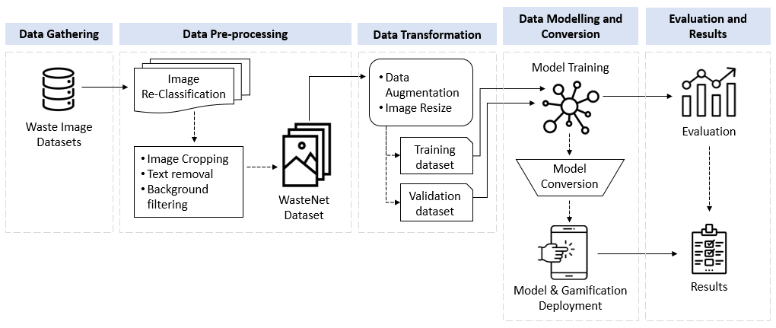
Fig. 1. Research Methodology
The first step, Data Gathering involves combining six waste image datasets [19], [20], [21], [22], [23], [24].
The second step, Data Pre-processing involves image re-classification, image cropping, text removal, and background filtering in order to ensure a clean image dataset. All the waste images were checked manually for misclassified images in each waste category. Misclassified images were reclassified accordingly. Images that contained unnecessary detail such as people and text labels were removed. Background texts and images of unrelated waste items were filtered out. After pre-processing the WasteNet dataset contained 33520 [25] waste images were re-numbered and saved in a JPG format and was compressed into a .zip file.
The third step, Data Transformation involves data augmentation and image resizing of the dataset that was then split into a training and validation datasets. Data augmentation involves reshaping and reconstructing the dataset in preparation for model training. The WasteNet dataset contained seven classes of waste namely e-waste with 1120 images, garbage with 655 images, glass with 3633 images, metal with 2956 images, organic with 12707 images, paper with 6592 images and plastic with 5853 images. Data augmentation was applied to the WasteNet dataset using ImageDataGenerator on TensorFlow. These included enabling shuffle = True, horizontal flip = True, zoom range = 0.2, rescale = 1./255, colour mode = “rgb” (3 – channels), batch size = 32 and random seed set at 20. Target size = (224, 224) or (299, 299) pixels depending on the model. The augmented WasteNet dataset was split into a ratio of 80:20 for training and validation.
The fourth step, Data Modelling and Conversion involves model training, model conversion, and model and gamification deployment. The models were trained with the splitted training dataset (26818 images) and testing it with the validation dataset (6702 images). Five pretrained models were imported from TensorFlow’s library for model training. ResNet152V2 [8], MobileNetV2 [9], DenseNet201 [10] and VGG19 [11] were trained with an image shape of (32, 224, 224, 3). InceptionResNetV2 [26] was trained with an image shape of (32, 299, 299, 3). Transfer learning was employed to maximise feature extraction and selection. To normalize the output of the neural network the models were trained with 10 epochs, categorical cross-entropy loss function, ReLU activation function and SoftMax activation function. The models were optimized using Adam optimizer. The trained models were then converted to a mobile compatible format using TensorFlow Lite. The post-training quantization [27] technique was applied to obtain a small-sized model, while still maintaining its performance. The trained models and gamification elements were deployed on a mobile device for multiple inference tests.
The fifth step, Evaluation and Results involves evaluating the performance of each of the deep learning image classification models using accuracy, loss, size and latency. The five models were compared and visualized using power BI. The optimal deep learning classification model was selected from the experimentation and integrated with the gamification elements.

Design Specification
The on-device deep learning framework architecture combines a deep learning image classification model and gamification elements as shown in Fig. 2. The components of the deep image classification model include captured image, deep learning model and inference as discussed in section 4.1. Components of the gamification elements are discussed in section 4.2.
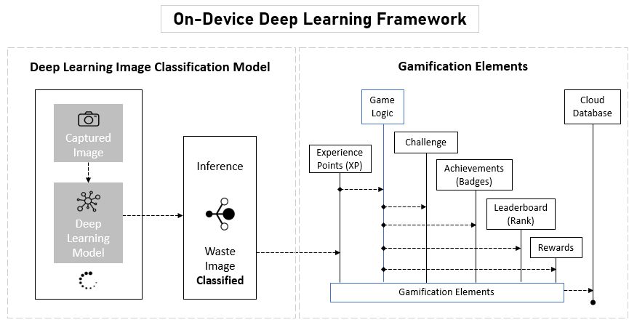
Fig. 2. On-Device Deep Learning Framework Architecture

Deep Learning Image Classification Model
Deep learning image classification model starts when a householder captures an image with the camera on a mobile device. The captured image is saved temporarily in a cache for the deep learning model to carry out an inference. The deep learning model of the framework is based on MobileNetV2, VGG19, DenseNet201, ResNet152V2 and InceptionResNetV2. An inference is generated by the deep learning model for a captured image by providing a corresponding accuracy to the classified waste category. To ensure that the waste class selected from the inference is precise, a confidence interval was set to 70%.

Gamification Elements
The gamification elements employed include experience points (XP), challenge, achievements (badges), leaderboard (rank) and rewards.
Experience points (XP) are generated based on the model’s inference of a classified waste item. Experience points are allocated based on each waste item. The game logic verifies the confidence of an inference that a waste item such as paper bag is part of a waste class paper. The game logic then checks the accuracy of the match between the waste item and the waste class. For instance, 10XP is generated when plastic waste is captured and successfully classified as plastic. The counter for the waste class is updated with the XP when inferences are successful. The summation of XPs for all waste classes represents the total points awarded to the householder. Based on the experience point generated, the programmed game logic activates relevant gamification elements such as challenges, achievements or badges, leaderboard (Rank). Challenges such as plant trees and save the sea were developed to encourage householders to actively classify waste in a game-like manner. For instance, the save the sea challenge encourages householders to prevent dumping of plastics into the sea.
Achievements or Badges are earned when a challenge is completed. For example, a shield badge is earned when a householder achieves 100XP on each of the seven-waste categories. Experience points generated over time are accumulated for the householder to qualify for a rank on the leaderboard. The Leaderboard (Rank) comprises of both global and local communities of friends. Ranks can earn a householder a badge of achievement. Rewards are activated for specific badges earned. Achievements can either have a virtual reward or monetary reward, that will be awarded to householders who have earned a corresponding badge of achievement.

Implementation
The on-device deep learning framework was implemented as an android mobile application called RecycliQ [28]. Screen designs and prototypes of the mobile application were designed using Adobe XD. Flutter is a cross-platform framework used to carry out application development. Flutter was setup on Visual Studio Code. The screen designs were exported to Visual Studio Code. Dart programming language was used to develop the game logic. A widget called Gesture detector was used to detect gestures to obtain input from the mobile camera when a user taps on the capture button. The trained deep learning model was converted and saved as a .tflite model. The model then runs inference on the captured waste image data. The model constantly retains data in the cache for quick inference when the camera is triggered. This contributes to the reason why the model size must be as small as possible. The game logic comprises of counters embedded in functions to constantly track and update XPs for successful inference of a waste class. The XPs are then made available to other gamification elements using shared preferences (Flutter package). Some of the interface of the mobile application includes a home page, leaderboard page and notification page as shown in Fig. 3. The leaderboard page shows the gamification elements. Additional gamification elements were created such as plant trees, save the sea, recycle quiz, earn crowns, waste trade, add friends and find recyclers.

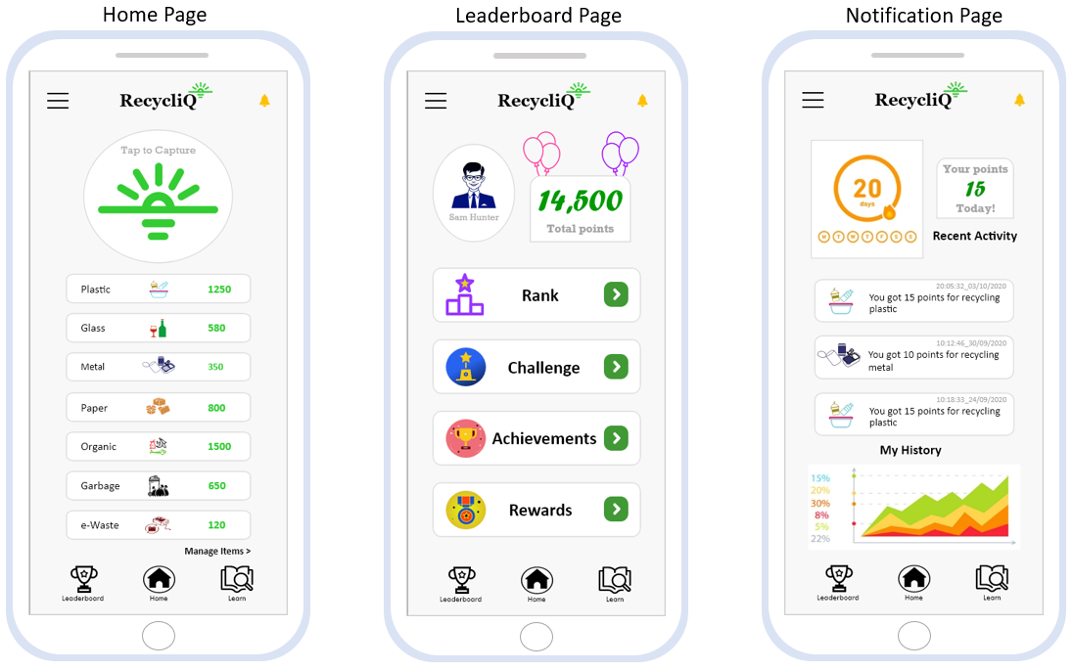
Fig. 3. RecycliQ Interface
The WasteNet dataset was uploaded to google drive. This dataset was imported from google drive into Google Co-laboratory (Colab) for pre-processing and model training as shown in Fig. 4. The TensorFlow models were trained with the WasteNet dataset and converted into an efficient format as a .tflite model using TensorFlow Lite. The .tflite model is usable by the interpreter with TensorFlow Lite’s converter for performing machine learning on a mobile device. The .tflite model was integrated with the mobile application and saved into the asset folder. A physical android mobile device used for carrying out multiple tests was Honor 7S.

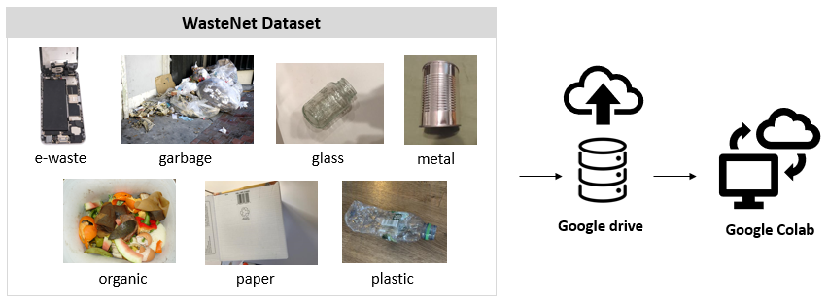
Fig. 4. WasteNet Implementation
A firebase Realtime Database (a cloud-hosted NoSQL database) was used for synchronising and storing the gamification elements such as experience points, leaderboard, achievements and rewards. The Firebase Realtime Database was also used for user authentication and storing users data in real time for further analytics.

Results and Discussion
The aim of this experiment is to compare MobileNetV2, VGG19, DenseNet201, ResNet152V2 and InceptionResNetV2 deep learning image classification models with the WasteNet dataset. Through the use of transfer learning technique, five pre-trained models were trained to recognize and classify waste images into seven classes of waste namely, e-waste, garbage, glass, metal, organic, paper and plastic.
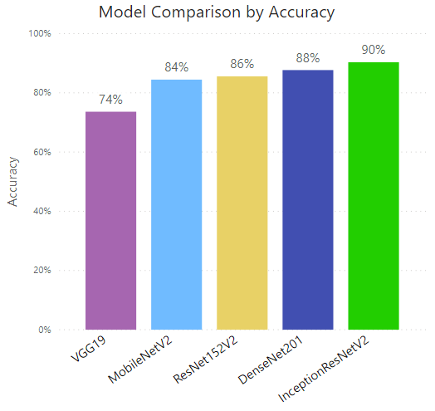
Fig. 5. Model Comparison by Accuracy
Fig. 5 shows the comparison of the five models based on accuracy. This result indicates that if InceptionResNetV2 model is applied for inference, images of waste items will be accurately classified the best at 90% into one of seven waste classes for recycling.
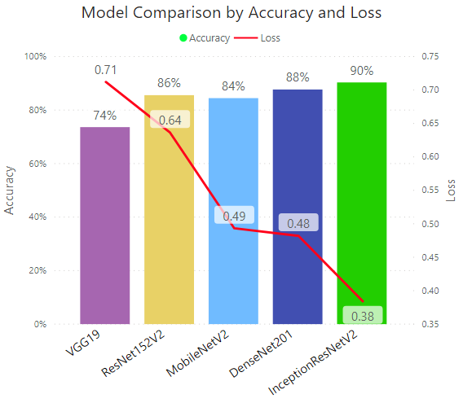
Fig. 6. Model Comparison by Accuracy and Loss
A comparison of the five deep learning models by accuracy and loss is shown in Fig. 6. Loss indicates how well or how poorly a model’s prediction is on each iteration of optimization. Therefore, the lower the loss, the better the model. The results show promise for InceptionResNetV2 with the best accuracy of 90% and the lowest minimum average loss function of 0.38 on waste images based on the calculated loss of the training and validation sets.

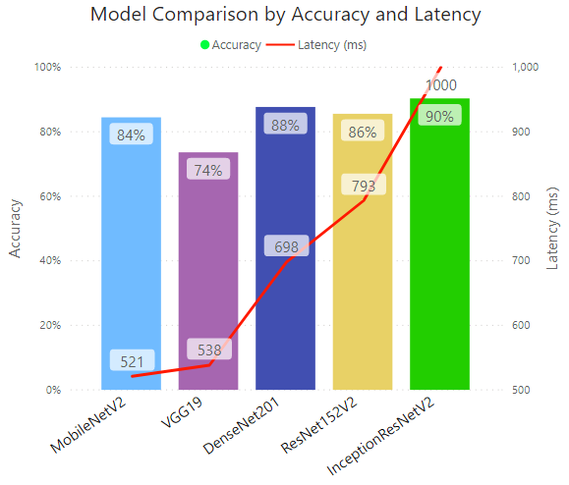
Fig. 7. Model Comparison by Accuracy and Latency
A comparison of the five deep learning models by accuracy and latency is shown in Fig. 7. Latency is the time in miliseconds for the model to make an inference. The lower the latency, the faster the model is able to carry out inference. InceptionResNetV2 has the highest accuracy but the worst latency at 1000ms. MobileNetV2 has the second worst accuracy at 84% but the lowest average latency at 521ms. DenseNet201 has the second best accuracy and third lowest average latency. The gamification elements requires an optimal model to classify waste images accurately while maintaining a small latency.
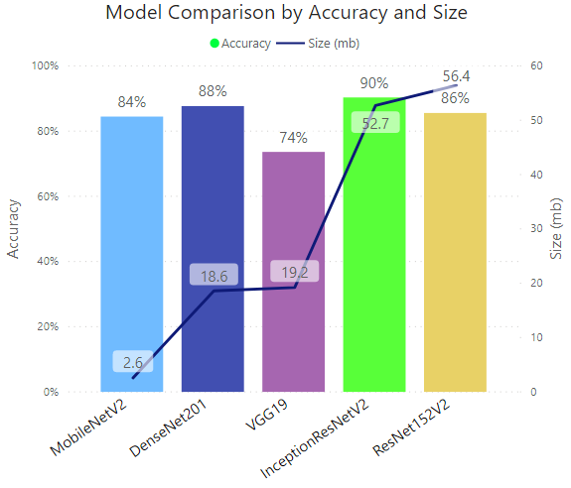
Fig. 8. Model Comparison by Accuracy and Size
A comparison of the five deep learning models by accuracy and size is shown in Fig. 8. Size is an important factor to consider, as it contributes to the overall application package when built. The integration of the deep learning model in a mobile application increases the size of the mobile application. The model itself should be as small as possible while maintaining good accuracy. MobileNetV2 at 2.6mb, had the lowest model size however it had the second last accuracy. DenseNet201 had the second best size and second best accuracy. DenseNet201 shows promise in terms of accuracy and size. This is attributed to design of the model’s mobile architecture [9]. The CPU’s cache memory constantly holds data for model’s inference. If the application generates to much data that overloads the cache memory, this increases power consumption on the mobile device. This could also affect the mobile device performance of householders, for devices without adequate mobile resources such as RAM and processor speed. DenseNet201 model had the second smallest size with an accuracy of 88%. The gamification elements require an optimal classification accuracy for precision of experience points (XP) generated.
The proposed on-device deep learning framework was developed to be deployed as a mobile application. Therefore, the model required to run an inference on waste images had to have high accuracy, minimal loss, low latency (for speed) and low size (to avoid overloading the mobiles’ CPU cache memory).
The characteristics of the deep learning image classification models would indicate that
- InceptionResNetV2 shows promise if the motivation is for accuracy, and accuracy and loss.
- MobileNetV2 and DenseNet201 show promise for accuracy and latency.
- MobileNetV2 and DenseNet201 show promise for accuracy and size.

Conclusion and Future Work
The aim of this research was to increase householder engagement to classify waste for recycling. This research proposes an on-device deep learning framework that combines a deep learning image classification model and gamification elements. Results demonstrate that InceptionResNetV2 shows promise if the motivation is for accuracy, and accuracy and loss; MobileNetV2 and DenseNet201 show promise for accuracy and latency; and MobileNetV2 and DenseNet201 show promise for accuracy and size. A limitations of this study insufficient waste image dataset to truly capture diverse real-world application.
This research can potentially enhance waste management, especially in developing countries. This work can be improved by optimising the models and establishing a statistical logic to select a final model for the framework based on the factors namely accuracy, loss, latency and size. Furthermore, an extensive research can be carried out on this work by developing an intelligent object detection model such as Faster R-CNN or YoloV5. An object detection model will enable the on-device deep learning framework to make inference on multiple objects simultaneously. This benefits householders, as they can generate more points by simply capturing multiple waste items in one image. For instance, a captured image with over ten plastic cups, five paper boxes, five batteries and three wine glass bottles, can all be detected and assigned corresponding experience points. In terms of object detection, more research has to be carried out to identify the optimal object detection model for waste detection.

References
- Godfrey, L., Nahman, A., Yonli, A.H., Gebremedhin, F.G., Katima, J.H., Gebremedhin, K.G., Osman, M.A.M., Ahmed, M.T., Amin, M.M., Loutfy, N.M., Osibanjo, O: Africa Waste Management Outlook. (2018).
- Lane, N.D., Bhattacharya, S., Mathur, A., Forlivesi, C., Kawsar, F.: DXTK: Enabling Resource-efficient Deep Learning on Mobile and Embedded Devices with the DeepX Toolkit. In MobiCASE. pp. 98–107 (2016).
- Santti, U., Happonen, A., Auvinen, H.: Digitalization boosted recycling: Gamification as an inspiration for young adults to do enhanced waste sorting. InAIP Conference Proceedings. 2233(1), pp. 050014. AIP Publishing LLC (2020).
- Yang, M., Thung, G.: Classification of trash for recyclability status. CS229 Project Report (2016).
- Adedeji, O., Wang. Z.: Intelligent waste classification system using deep learning convolutional neural network. Procedia Manufacturing. vol. 35, pp. 607–612 (2019).
- Bircanoğlu, C., Atay, M., Beşer, F., Genç, Ö., Kızrak, M.A.: RecycleNet: Intelligent waste sorting using deep neural networks. In 2018 Innovations in Intelligent Systems and Applications (INISTA). pp. 1–7. IEEE (2018).
- Lane, N.D., Bhattacharya, S., Mathur, A., Georgiev, P., Forlivesi, C., Kawsar, F.: Squeezing deep learning into mobile and embedded devices. IEEE Pervasive Computing. 16(3), pp. 82-88 (2017).
- He, K., Zhang, X., Ren, S., Sun, J.: Deep residual learning for image recognition. Proceedings of the IEEE conference on computer vision and pattern recognition. pp. 770–778 (2016).
- Sandler, M., Howard, A., Zhu, M., Zhmoginov, A., Chen, L.C.: Mobilenetv2: Inverted residuals and linear bottlenecks. In Proceedings of the IEEE conference on computer vision and pattern recognition. pp. 4510–4520 (2018).
- Huang, G., Liu, Z., Van Der Maaten, L., Weinberger, K. Q.: Densely connected convolutional networks. In Proceedings of the IEEE conference on computer vision and pattern recognition. pp. 4700–4708 (2017).
- Simonyan, K., Zisserman, A.: Very deep convolutional networks for large-scale image recognition. arXiv preprint arXiv:1409.1556 (2014).
- Guo, T.: Cloud-based or on-device: An empirical study of mobile deep inference. 2018 IEEE International Conference on Cloud Engineering (IC2E). pp. 184–190. IEEE (2018).
- Deng, Y.: Deep learning on mobile devices: a review. In Mobile Multimedia/Image Processing, Security, and Applications 2019. International Society for Optics and Photonics, vol. 10993, pp. 109930A (2019).
- Deterding, S., Dixon, D., Khaled, R., Nacke, L.: From game design elements to gamefulness: defining “gamification”. In Proceedings of the 15th international academic. MindTrek conference: Envisioning future media environments. pp. 9–15 (2011).
- Hsu, J.: How gamification has catapulted Duolingo, Strava, and Forest to the top of their respective app categories, https://citrusbits.com/how-gamification-has-catapulted-duolingo-strava-and-forest-to-the-top-of-their-respective-app-categories/, last accessed 2020/08/04.
- Francisco-Aparicio, A., Gutiérrez-Vela, F.L., Isla-Montes, J.L., Sanchez, J.L.G.: Gamification: analysis and application, New trends in interaction, virtual reality and modelling, Springer. pp. 113–126, (2013).
- Zichermann, G., Cunningham, C.: Gamification by design: Implementing game mechanics in web and mobile apps. O’Reilly Media, Inc. (2011).
- Mekler, E.D., Brühlmann, F., Tuch, A.N., Opwis, K.: Towards understanding the effects of individual gamification elements on intrinsic motivation and performance. Computers in Human Behavior. 71, pp. 525–534 (2017).
- Dataset1 (Trashnet Dataset) – Source: https://github.com/garythung/trashnet, last accessed 2020/07/11.
- Dataset2 (Drinking wase classification data) – Source: https://www.kaggle.com/arkadiyhacks/drinking-waste-classification , last accessed 2020/07/12.
- Dataset3 (Waste classification data) – Source: https://www.kaggle.com/techsash/waste-classification-data, last accessed 2020/07/21.
- Dataset4 (Open-recycle dataset) – Source: https://github.com/openrecycle/dataset, last accessed 2020/07/21.
- Dataset5 (Spot-garbage data) – Source: https://github.com/spotgarbage/spotgarbage-GINI, last accessed 2020/07/21.
- Dateset6 (Getty Images, e-waste photos) – Source: https://www.gettyimages.ie/photos/e-waste, last accessed 2020/08/26.
- Ekundayo, O., Murphy, L., Pathak, P., Stynes, P.: WasteNet dataset. (2021). https://drive.google.com/file/d/1MsYNz6TnJldHdkj_sbBejxK3l23wYkkH/view?usp=sharing, last accessed 2021/01/09.
- Szegedy, C., Ioffe, S., Vanhoucke, V., Alemi, A.: Inception-v4, inception-resnet and the impact of residual connections on learning. In Proceedings of the AAAI Conference on Artificial Intelligence 31(1). (2017).
- Zhou, S.C., Wang, Y. Z., Wen, H., He, Q.Y., Zou, Y.H.: Balanced quantization: An effective and efficient approach to quantized neural networks. Journal of Computer Science and Technology 32(4), pp. 667–682. (2017).
- Ekundayo, O., Murphy, L., Pathak, P., Stynes, P.: RecycliQ – Mobile Application Development, (2021). https://drive.google.com/drive/folders/1VoLGhkhdih2TEMJGQ5YUm88hqe3BcSzH?usp=sharing, last accessed 2021/01/09.

